Q2)

TRANSFER FUNCTION OF FLYBACK CONVERTER

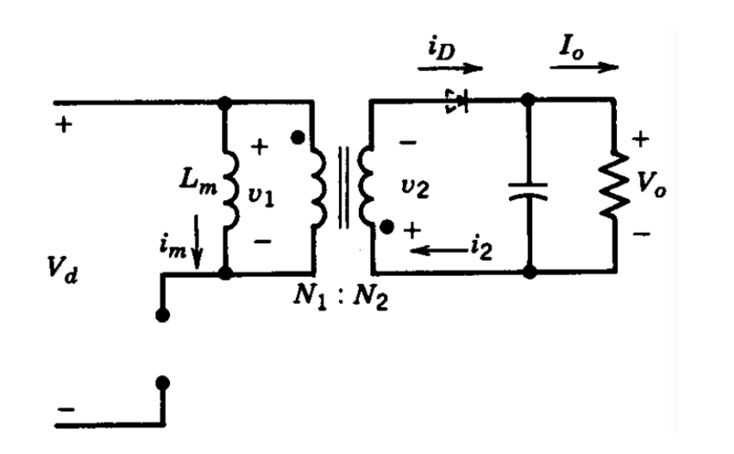

Figure 2.1: Flyback Converter Schematic

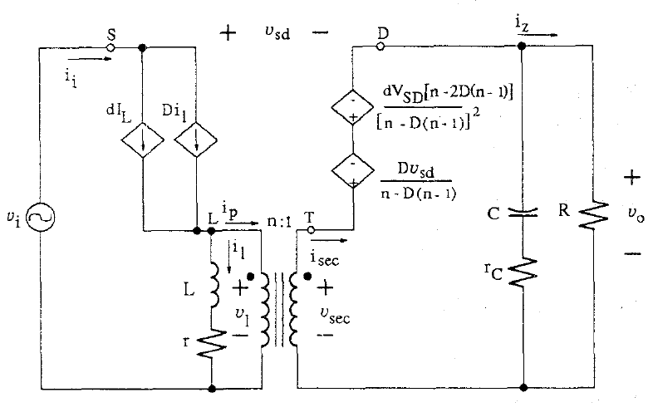

Figure 2.2: Small Signal Model of Flyback Converter

We choose n=1 and circuit schematic will be like that;

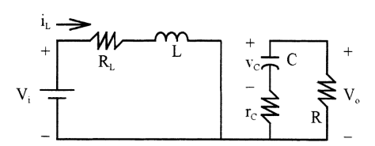

Figure 2.3: Switch ON State When n=1

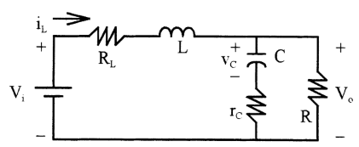

Figure 2.4: Switch OFF State When n=1

By looking ON state:

$-Vi+R_{L}*i_{L}+L\hat{iL}=0$ (1)

$C\hat{Vc}*\left(R+rc\right)+Vc=0$ (2)

By using Eq. (1) and (2)

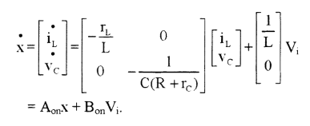

By looking OFF state:

$i_{L}*R_{L}+L*\hat{iL}+R\left(i_{L}-C*\hat{Vc}\right)=0$ (3)

$-Vc+R\left(i_{L}-C*\hat{Vc}\right)-C*\hat{Vc}*rc=0$ (4)

By using Eq. (3) and (4)

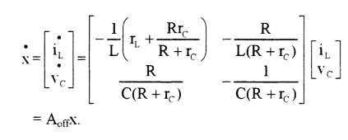

(5)

V0 = [] (6)

A=AON\*D+AOFF\*(1-D) (7)

B=BON\*D+BOFF\*(1-D) (8)

C=CON\*D+COFF\*(1-D) = [ $\begin{matrix}R*rc/(R+rc) & \frac{R}{R+rc}\end{matrix}]$ (10)

$T\left(s\right)=\frac{V_{0}}{V_{i}}=-CA^{-1}B$ (11)

By using Eq. (7), (8), (9), (10) and (11),

T(s) is that form.

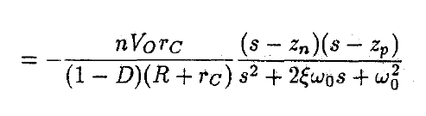 (12)

(n=turn ratio)

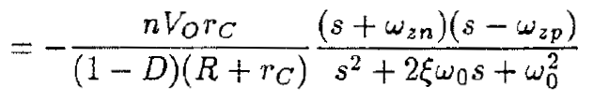

(13)

Where the frequency of negative pole:

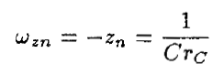 (14)

And the frequency of negative pole:

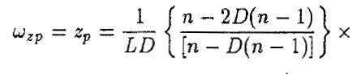 (15)

Angular corner Frequency:

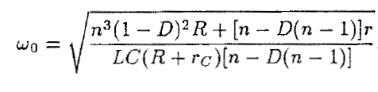 (16)

Damping Ratio:

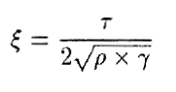 (17)

Where,

 (18)

 (19)

 (20)